H.T No
Regulations:
A15

Sreenidhi Institute of Science and Technology
(An Autonomous Institution)
Code No: 5F302 Date: 02-Sept-2023 (FN)

B.Tech II-Year I- Semester External Examination, Aug/Sept - 2023 (Supplementary)
Mathematical Foundations of Computer Science (CSE and IT)

Time: 3 Hours Max.Marks:75

Note: a) No additional answer sheets will be provided.
b) All sub-parts of a question must be answered at one place only, otherwise it will not be valued.
c) Missing data can be assumed suitably.

Bloom's Cognitive Levels of Learning (BCLL)

Remember | L1 | Apply | L3 | Evaluate | L5
Understand | L2 | Analyze | L4 | Create | L6

Part - A Max.Marks:25
Answer all QUESTIONS

 |  | BCLL | CO(s) | Marks
1 | Find the Conjunctive Normal Form of 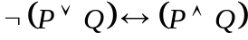. | L5 | CO1 | [2M]
2 | Determine whether the sequence 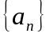 is a solution of the Recurrence Relation 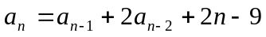, if 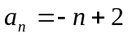. | L5 | CO2 | [2M]
3 | Define the following.  i) Lattice ii) Sublattice iii) Lattice as an algebraic system | L2 | CO3 | [2M]
4 | Define Cosets and Homomorphism of groups. | L1 | CO4 | [2M]
5 | Define Directed tree and Binary tree. | L1 | CO5 | [2M]
6 | Define Planar graph with an example. | L1 | CO6 | [3M]
7 | Write the Inverse and Contrapositives of the implication “If I get grade A in this course then my father praises me.” | L1 | CO1 | [3M]
8 | Define Compatability relation with an example. | L1 | CO3 | [3M]
9 | State Euler’s Formula. | L1 | CO6 | [3M]
10 | Define Semigroup with an example. | L1 | CO2 | [3M]
Part – B Max.Marks:50
ANSWER ANY FIVE QUESTIONS. EACH QUESTION CARRIES 10 MARKS.

 |  |  | BCLL | CO(s) | Marks
11. | a) | Verify the Equivalence between the premises  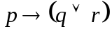 and 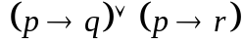 | L4 | CO1 | [5M]
 | b) | Show that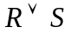follows logically from the premises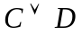,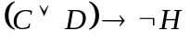,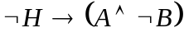 and 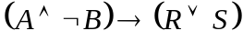. | L4 | CO1 | [5M]
12. | a) | Verify the validity of the following argument: “All men are mortal. Socrates is a man. Therefore, Socrates is mortal.” | L3 | CO2 | [5M]
 | b) | Solve the Recurrence Relation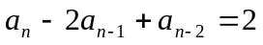. | L4 | CO2 | [5M]
13. | a) | Draw the Hasse diagram for positive divisors of 24. | L3 | CO3 | [5M]
 | b) | Explain about Boolean expressions and functions with examples. | L2 | CO3 | [5M]
14. | a) | Explain about Monoid and Submonoid with giving an example each. | L2 | CO4 | [5M]
 | b) | State and prove Lagrange’s theorem. | L1 | CO4 | [5M]
15. | a) | Verify whether the following graphs are Isomorphic or not.  a¹  G₂  d  c  e  b¹  c¹  d¹  e¹  G₁  a  b | L3 | CO5 | [5M]
 | b) | Find the BFS Spanning tree for the following graph.  V₃  V₅  V₆  V₂  V₁  V₄  V₇ | L5 | CO5 | [5M]
16. | a) | Find the Euler path to the following graph.  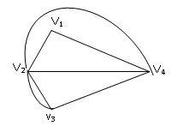 | L5 | CO6 | [5M]
 | b) | Find the Chromatic number for the following graph.  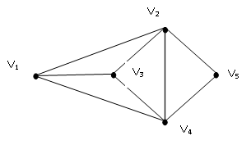 | L5 | CO6 | [5M]
17. | a) | Explain about Tautological implications. | L2 | CO1 | [3M]
 | b) | Symbolize the following Arguments.  i) Gold and Silver ornaments are precious. ii) Not all rainy days are cold.  iii) Lions are dangerous animals. | L3 | CO2 | [4M]
 | c) | Let 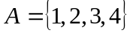and 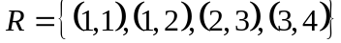, 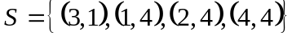 be the relations on A. Determine (i) M(R) (ii) R○S (iii) R² | L3 | CO3 | [3M]
18. | a) | Explain about Algebraic system with an example. | L2 | CO4 | [4M]
 | b) | Discuss about Bipartite and Complete Bipartite Graphs. | L3 | CO5 | [3M]
 | c) | Draw the following.  i) A graph which is Both Hamiltonian and Eulerian.  ii) A graph which is Hamiltonian but not Eulerian. | L2 | CO6 | [3M]

-- 00 -- 00 –

